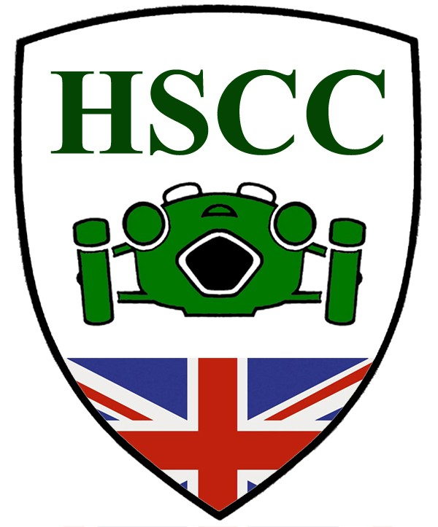

We are pleased that you will be racing with the HSCC in 2011.

It is generally agreed that the HSCC has higher driving standards than most other clubs and championships. However we are determined to make them even better. We would like to enlist your help by considering these five simple points.

- When you get the 2011 Blue Book please read it and make yourself aware of the MSA rules. They exist for your safety and enjoyment so please follow them.
- HSCC historic racing is a non-contact sport. We like your cars and don’t want them to be damaged.
- Remember that the driver running last is just as important to the Club as the driver in the lead.
- When cornering give your fellow competitors a safety margin so they can have their own mistakes.
- When you exit a corner, pick a position on the straight, don’t move again before the next corner, don’t weave to ‘cover off’ competitor moves.

We’ll be monitoring progress through the season. We will be asking Observers to report weaving and all competitors involved in ‘car to car’ and ‘car to scenery’ incidents. You can expect that any driver so reported will be invited to Race Control to discuss the incident.

Enjoy your season in 2011.

